Your sight was restored by an extraordinary gift.
A donor's decision — and the work of your local eye bank — made your corneal transplant possible. There's a community behind your surgery, and they'd love to connect with you.
Connect with your eye bank
Your eye bank can answer your questions, help you reach out to your donor's family, and share ways to get involved.
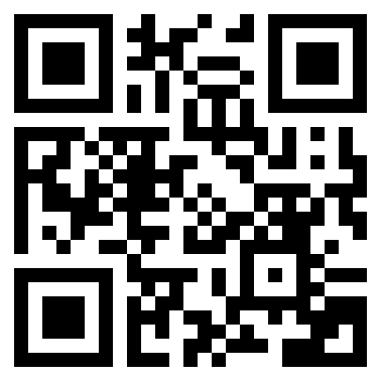
[QR CODE]

[Eye Bank Name] Eye Bank Association of America
[website] RestoreSight.org
Learn more about eye donation The Eye Bank Association of America has resources to help you understand your, your donor's gift, and how you can give back.
This resource was developed by the Eye Bank Association of America in partnership with [Eye Bank Name], and was made transplant possible by a grant from the Bausch Foundation.

