Order Form
Your Order
Item Description Unit Cost Min Order Quantity Price
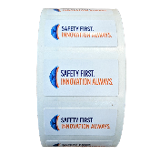
Small Labels
.75” tall x 1.5” wide $3.75/roll 1 roll ____ _____
150 labels per roll

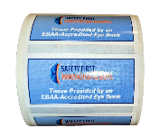
Large Labels
1.5” tall x 3” wide $9.00/roll 1 roll ____ _____
150 labels per roll

Packing Tape
55 yards $3.50/roll 10 rolls ____ _____
*10% case discount* $113.40/case 1 case (36 rolls) ____ _____

Cotton Mask
two-layer cotton mask $5.75/mask 10 masks ____ _____

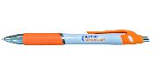
Ballpoint Pen
blue ink $.89/pen 25 pens ____ _____

Total _____
USPS fees will be charged at our actual cost and applied to your payment card upon shipment.
Delivery and Payment
Name:___________________________________________________________________________
Eye Bank:_________________________________________________________________________
Address:__________________________________________________________________________
Credit Card:______________________________________ Exp:___________ CVC:___________
Name on Card:____________________________________________________________________

Please fax orders to 202-429-6036 or email to Bernard@restoresight.org

