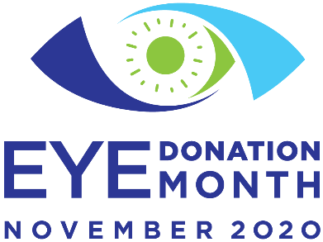

It all starts with registering to be an eye, organ and tissue donor and sharing your decision with your family and loved ones.

During Eye Donation Month, [eye bank] will promote cornea donation and transplantation awareness; encourage individuals to register as eye, organ and tissue donors; honor donors and their families; and celebrate cornea recipients. We have several stories to share with media.

**[insert quote from eye bank director, share a story]**

About [Eye Bank]

***Editors please note:***

**November 2020**

**Eye Donation Month** [www.eyedonationmonth.org](http://www.eyedonationmonth.org/) **#eyedonationmonth2020**

**SAMPLE MEDIA ADVISORY**

[insert eye bank contact name, phone, email]

**November is Eye Donation Month**

**[Eye Bank] to Raise Awareness in the Community**

**[DATE], 2020 – [City/State] --** November 2020 is Eye Donation Month, and the [Eye Bank] will be raising awareness about the life-changing opportunities that are created through eye donation.

**Eye Donation Month 2020** will focus on the community of people make the gift of sight possible. Eye bank staff, funeral directors, medical examiners/coroners, hospital administrators, cornea donor families and cornea recipients are the enduring champions for the millions of people around the world whose lives were transformed through cornea donation and transplantation.

**Quick Facts:**

•

•

There are **[number]** eye banks in **[state]** that recover and provide transplantable tissue to

**[state]**’s citizens.

Last year, through cornea donation from fellow **[state]** residents, our eye banks provided **[total number of corneas transplanted in your state]** to help fellow **[state demonym]**, and patients around the world, regain their sight.

Almost anyone can be a cornea donor, regardless of vision, age, or past ocular health issues such as cataracts or laser vision correction.

The transplants performed each year increase their recipients’ productivity and reduce their

•

•

healthcare costs, contributing $6 billion in benefits to the US healthcare system.

**eyedonationmonth.org**

**#eyedonationmonth**