* An eye bank is a nonprofit organization that obtains, medically evaluates and distributes corneas donated by caring individuals for use in corneal transplantation, research, and education.
* Each year, millions of people around the world have their lives transformed through cornea donation and transplantation. In 2019, 85,601 corneas were provided for transplant with a more than 95 percent success rate, providing $6 billion in lifetime economic benefit for the recipients. In 2019, there were 68,759 U.S. donors of ocular tissue.
* Eye, tissue, and organ donor registration can be done via registerme.org individual state registries, or through the Department of Motor Vehicles. It is important for prospective donors to notify family of their decision because the family’s cooperation during a medical/social history interview is required before transplantation.
* The entire eye can be used for research and education, potentially helping untold thousands of people regain their sight as researchers develop new understanding of the causes and effects of eye conditions that lead to blindness.

“Eye donation” doesn’t mean the entire eye is transplanted; instead, only the cornea (the clear, dome-shaped surface that covers the front of the eye) is replaced, restoring sight for those with cornea-related blindness.

Eye Donation Month raises eye donation awareness, honors donors, celebrates recipients, and acknowledges eye bank and physician efforts in the donation process.

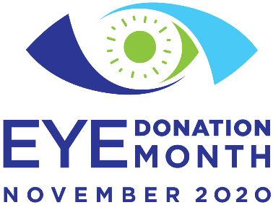

**MEDIA TALKING POINTS**

November 2020 is Eye Donation Month, and the Eye Bank Association of America (EBAA) and member eye banks throughout the U.S. and internationally will be raising awareness about the life-changing opportunities that are created through eye donation.

**eyedonationmonth.org**

**#eyedonationmonth**