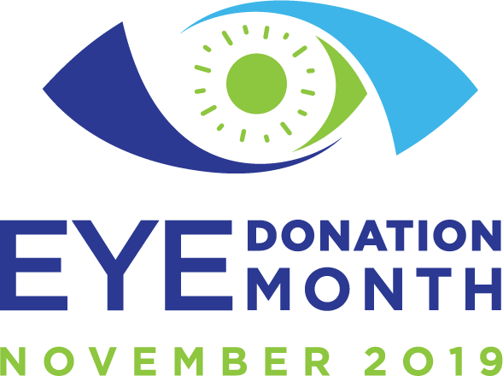

**SAMPLE EMAIL ABOUT EYE DONATION MONTH TO MEDIA CONTACTS**

Dear (use their personal name and customize each email):

Eye Donation Month will be held in November 2019. Throughout the month, the [insert name of eye bank] will raise awareness about the importance of eye donation,

misperceptions about the process, and life-changing opportunities that are created when recipients regain their sight through cornea transplants.

Last year, the [insert name of eye bank] provided [number] cornea transplants to individuals throughout our [city/state]. In fact, we have many stories about successful transplants to share with local media:

[insert story] – link to story

**Each year, millions of people around the world have their lives transformed through cornea donation and transplantation. In 2018, 85,441 corneas were provided for transplant with a more than 95 percent success rate, providing $6 billion in lifetime economic benefit for the recipients.**

Experts at the [insert eye bank] can share detailed information with your [viewers/readers] about eye donation and connect you with individuals who have received the gift of sight or who are involved in the process.

Please contact to schedule an interview.

Thank you!

**eyedonationmonth.org**

**#eyedonationmonth**