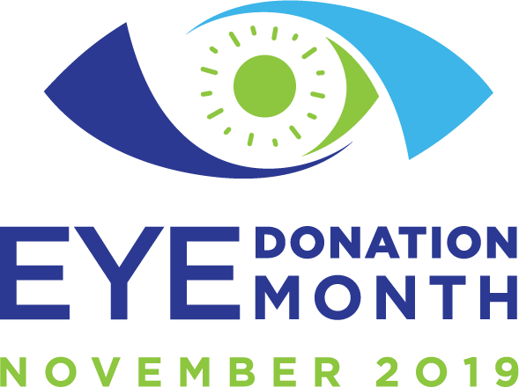

**GOVERNOR PROCLAMATION SAMPLE LETTER**

**[Eye Bank Logo(s) across top of page]**

The Honorable **[name]** – *use “Your Excellency” for Massachusetts and South Carolina Governors*

Governor of **[state] [address line 1]**

**[address line 2] [city, state zip code]**

Dear Governor **[surname]:**

For 58 years, the Eye Bank Association of America (EBAA) and its members have set standards, provided education, and engaged in advocacy to support eye donation and cornea transplantation and research. As the leading voice of the eye banking community, EBAA and its 75 member banks request **[state]**’s support on behalf of the eye banking community’s vision of restoring sight and eliminating corneal blindness worldwide.

EBAA promotes November as “Eye Donation Month” annually to raise eye donation awareness, honor donors, celebrate recipients, and acknowledge eye bank and physician efforts in the donation process. Since being proclaimed the first National Eye Donor Month in 1983, a member of Congress has read a proclamation into the Congressional Record to support eye donation.

The eye banking community knows firsthand the profound effect of sight-restoring corneal transplants, which changes lives. In 2018, 85,441 corneas were provided for transplant with a more than 95 percent success rate, providing $6 billion in lifetime economic benefit for the recipients.

There are **[number of eye banks in your state]** eye banks in **[state]** that recover and provide transplantable tissue to **[state]**’s citizens. Last year, through cornea donation from fellow **[state]** residents, our eye banks provided **[total number of corneas transplanted in your state]** to help fellow **[state demonym]**, and patients around the world, regain their sight.

The efforts of EBAA, its member banks, corneal surgeons, and certified eye bank technicians (CEBTs) have contributed to advancements in corneal surgery. Our industry-leading medical standards, acknowledged and respected by government and peers alike, have also contributed to the efficacy and safety of corneal tissue. These achievements would not have been possible without the selfless gifts of donors and donor families, the dedication of eye bankers, corneal surgeons and CEBTs, and the support of those like you, who assist us in increasing eye donation awareness.

We would be honored if you would declare November 2019 as “Eye Donation Month” in **[state]**. **[state demonym]** have long benefited from sight-restoring corneal transplants; with your support to increase eye donation awareness, many more will be afforded the same opportunity.

If you have any questions, please do contact one of us or Colleen Bayus in the EBAA office at 202-775- 4999, ext 118.

Thank you in advance for your participation.

Sincerely,

[ED Signature]

[ED Signature]

[ED Signature]

[ED Name] [Telephone Number]

[ED Name] [Telephone Number]

[ED Name] [Telephone Number]

**eyedonationmonth.org**

**#eyedonationmonth**